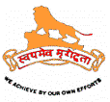HINDU SWAYAMSEVAK SANGH

presents…

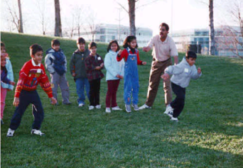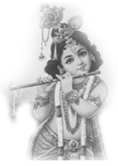Balagokulam

A weekly activity for all…

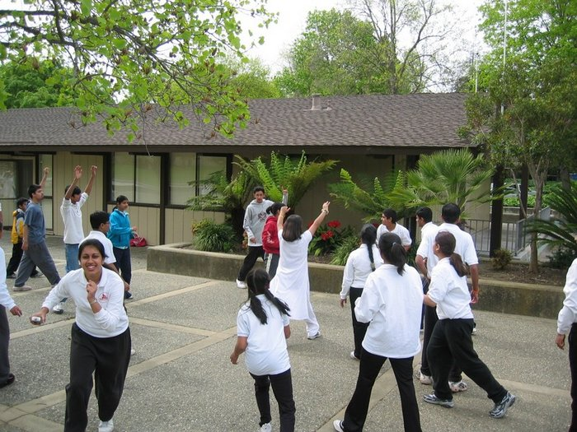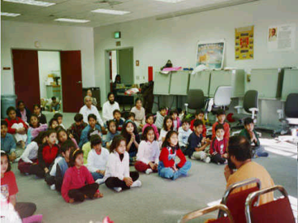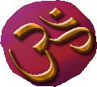Hindu Swayamsevak Sangh (HSS) is a voluntary, non-profit, social, cultural organization that aims to organize the Hindu community in order to practice and promote Hindu ideals and values.

Youth Volunteers

**Shakha** is a weekly program for the entire family where there are activities for physical, mental and psychological well being. These include yoga, games, shlokas, songs, discussions, stories, etc.

**For more information, contact:**

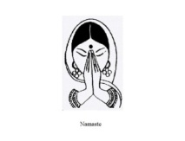For more information, please visit:  
[www.hssus.org](http://www.hssus.org)   
[www.balagokulam.hssus.org](http://www.balagokulam.hssus.org)

*“Where else besides shakha could you go to build leadership skills, meet new people, learn more about Hindu culture and have fun all at the same place?”* - Sonia Gosain, 18